Application Guide
for Entry in
2021 Fall Semester

Greetings from Sunchon National University!
I, Jiyeon Chun, dean of the institute of international affairs and education, am deeply grateful for your consideration every year.
Sunchon National University invites the outstanding students from sister universities every year and runs various beneficial programs to learn Korean language and culture.
I hope that many students could have a chance to learn about Korea through the student exchange programs in Sunchon National University.

Sincerely,
Jiyeon Chun
Dean
Institute of International Affairs and Education

1. Summary
○ Period : September 1, 2021 ~ December 17, 2022 (6 months)
: September 1, 2021 ~ June 17, 2022 (1 year)
○ Eligibility : Enrolled students from sister universities
○ Coverage : Exemption for tuition (not including dormitory fee, insurance fee and living expenses, etc.)

2. Tuition Payment
Tuition | Dormitory (Double-occupancy) |  | Insurance | Remark
 | 1 Semester
Exemption | KRW 1,000,000 (USD $850) | Including meals | KRW140,000/1 Year | Not including  living expenses
 | KRW 500,000 (USD $430) | Not Including meals
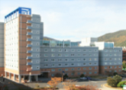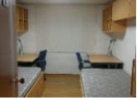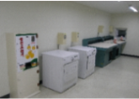

3. Application guide
○ Application deadline : 23th. April. 2021
○ How to apply : by E-mail kjs5520@scnu.ac.kr
○ Application documents : Application form, Study plan, copy of passport, Scanned copy of photo, Certificate of Enrollment(English), Transcript(English)

○ Admission process
❶ Submit application  and VISA documents  (March and April) | ➡ | ❷ Examine  documents  (Eligibility, etc.) | ➡ | ❸ Notify  successful applicants | ➡ | ❹ Send documents  such as admission letter  (Univ. → student) | ➡

❺ (Student) Apply  VISA with required  documents | ➡ | ❻ Enter Korea  (Free pick-up from the airport) | ➡ | ❼ Take courses  (September)

4. Contact and Inquiries
- Telephone: +82-61-750-3142
- E-mail: kjs5520@scnu.ac.kr

